MTH001 – ELEMENTRY MATHEMATICS
  - 1ST Assignment A | Ms. Aisha (Instructor)

Q1. Represent the following argument in symbolic form and by using the truth table determine whether the argument is valid or invalid. Justify your answer with proper reasoning.

If you are a billionaire then you can buy this hotel. You are not a billionaire. Therefore, you cannot buy this hotel.

Solution
$$p="You are a billionaire."$$
$$q="You can buy this hotel."$$

Premise 1:
$$p → q (If you are a billionaire, then you can buy this hotel.)$$

Premise 2:
$$¬p (You are not a billionaire.)$$

Conclusion:
$$¬q (Therefore, you cannot buy this hotel.)$$
$$p$$ | $$q$$ | $$p→q$$ | $$¬p$$ | $$¬q$$
T | T | T | F | F
T | F | F | F | T
F | T | T | T | F
F | F | T | T | T

Since there is one row in the truth table where all premises are true and the conclusion is false, the argument is invalid.

Q.2 Given the directed graph define the corresponding relation R and check whether the relation is reflexive and symmetric? Justify your answer with proper reasoning.
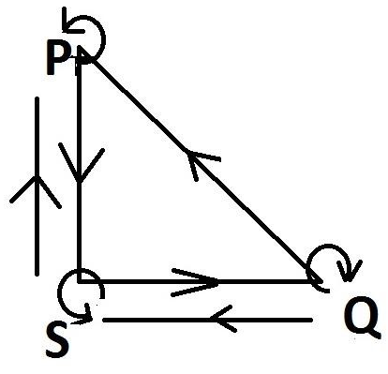

Solution
For this particular graph, let's define the relation $R$ as follows:
$$R = \{\left(P,P\right),\left(P, S\right), \left(S, P\right),\left(S,S\right), \left(S, Q\right), \left(Q, S\right),\left(Q,Q\right),(Q,P)\}$$
Relation $R$ is reflexive as for every element $x$ in $R$, $(x, x)$ is also in $R$, but it is not symmetric as for every pair $(x,y)$ in $R$ there is no $(y,x)$ in $R$.

